

MOBILE COMPUTING 2025

**APPLICATION DEVELOPMENT WITH ANDROID STUDIO**

**(MINI PROJECT)**

|  |  |
| --- | --- |
| Roll. No.: B32 | Name: Mahesh Suresh Bhosale |
| Class: TE B COPMS | Batch: B2 |
| Date of Experiment: | Date of Submission: |
| Grade: | |

**NEWS APP**

**Aim:** To develop a **News App** that provides users with real-time, categorized, and news updates by integrating external news APIs. The application will feature a user-friendly interface, efficient search functionality, and customizable news feeds to enhance the reading experience.

**Objectives:**

• **To Introduce Android App Development Concepts**

* Familiarize students with **Android Studio**, **Kotlin**, and **Jetpack Compose** for app development.
* Understand **project structure, Gradle build system, and manifest configurations**.

• **To Implement a Real-Time News Fetching System**

* Integrate **NewsAPI** (or similar sources) using **Retrofit** to fetch the latest news dynamically.
* Use **JSON parsing** with Gson or Moshi to process and display news articles efficiently.

• **To Develop an Intuitive & Engaging User Interface**

* Design an easy-to-navigate UI using **Jetpack Compose / XML layouts**.
* Implement **RecyclerView** for displaying a list of news articles smoothly.
* Provide a **dark mode** feature for enhanced readability.

• **To Implement News Filtering & Personalization**

* Enable users to filter news by **categories** (e.g., Sports, Technology, Business).
* Implement a **search bar** for quick access to specific news articles.
* Allow users to **bookmark** articles for offline reading.

• **To Enhance User Experience with Push Notifications**

* Integrate **Firebase Cloud Messaging (FCM)** to notify users about breaking news.
* Ensure notifications are **timely and relevant** to avoid user fatigue.

• **To Implement Efficient Data Storage & Performance Optimization**

* Use **Room Database** for offline caching and smooth content retrieval.
* Optimize app performance with **background processing using WorkManager**.
* Reduce data usage by implementing **lazy loading and pagination**.

• **To Introduce Deployment & Testing Practices**

* Debug and test the app using **Android Emulator and real devices**.
* Learn how to generate a **signed APK** for deployment on the **Google Play Store**.

**Outcome:** After the successful completion of this project, students will be able to:

1. **Develop and Deploy an Android News Application**
   * Build a fully functional **News App** using **Android Studio** and deploy it on real devices.
2. **Integrate and Handle APIs Efficiently**
   * Fetch and display real-time news using **NewsAPI** with **Retrofit/Volley** for seamless data retrieval.
3. **Design and Implement a User-Friendly Interface**
   * Develop an intuitive UI using **Jetpack Compose/XML layouts** with smooth navigation and category-based filtering.
4. **Enhance User Experience with Key Features**
   * Implement **search functionality, real-time filtering, bookmarking for offline reading, and dark mode**.
   * Use **Firebase Cloud Messaging (FCM)** to enable push notifications for breaking news.
5. **Implement Local Data Storage and Performance Optimization**
   * Utilize **Room Database** for offline caching, ensuring users can access saved articles without an internet connection.
   * Optimize app performance using **background processing with WorkManager and pagination techniques**.
6. **Test and Debug Applications Effectively**
   * Use **Android Emulator, Logcat, and Profiler** for debugging and performance optimization.
7. **Deploy the Application Successfully**
   * Learn to generate a **signed APK** and prepare the app for **Google Play Store deployment**.

# Theory:

#### **1. Introduction to News Apps**

A **News App** is a mobile application that provides users with real-time access to the latest news and updates from various sources. With the increasing reliance on mobile devices for information consumption, news apps have become a crucial medium for delivering content in an efficient, user-friendly manner.

This project involves building an Android-based **News App** that fetches real-time news articles using **NewsAPI** and presents them in a structured, user-friendly format. The app will allow users to browse news articles, filter them based on categories, search for specific topics, and even save articles for offline reading.

#### **2. Technologies Used in News App**

##### **a) Android Studio**

Android Studio is the official **Integrated Development Environment (IDE)** for Android development. It provides tools for designing, coding, testing, and debugging Android applications. Features like **Gradle Build System, Layout Editor, and Emulator** make it a powerful tool for app development.

##### **b) Programming Language: Kotlin**

Kotlin is the preferred language for modern Android development due to its **concise syntax, enhanced safety features, and compatibility** with Java. It simplifies UI development and improves performance compared to traditional Java-based apps.

##### **c) Jetpack Compose & UI Components**

* **Jetpack Compose** is a modern UI toolkit that simplifies UI design by using a declarative approach.
* The app includes essential UI components like **RecyclerView, CardView, and ViewPager** for displaying news articles in a visually appealing way.

##### **d) API Integration with Retrofit**

* **Retrofit** is a powerful HTTP client for handling API requests.
* The app fetches news data from **NewsAPI** in **JSON format**, which is parsed using **Gson or Moshi**.

##### **e) Local Database with Room**

* **Room Database** is used for offline storage of bookmarked news articles.
* This ensures users can read saved articles even without an internet connection.

##### **f) Firebase Cloud Messaging (FCM)**

* Push notifications are implemented using **Firebase Cloud Messaging (FCM)** to keep users informed about breaking news.

#### **3. Architecture of the News App**

##### **a) Model-View-ViewModel (MVVM) Architecture**

The project follows the **MVVM architecture** to ensure better code organization and maintainability:

* **Model:** Handles data processing and API integration.
* **View:** Represents the UI components and displays data to users.
* **ViewModel:** Acts as an intermediary, managing UI-related data and logic efficiently.

##### **b) Data Flow and API Calls**

* The app fetches data from **NewsAPI** and displays it using **RecyclerView**.
* API requests are handled by **Retrofit**, which retrieves data in JSON format.
* The data is then parsed and displayed on the UI.

## SOFTWARE/HARDWARE Requirements:

### **Software Requirements**

1. **Development Platform:**
   * **IDE:** Android Studio (latest stable version)
   * **Build System:** Gradle
   * **Version Control:** Git/GitHub
2. **Programming Languages:**
   * **Primary:** Kotlin
   * **Secondary:** Java (for legacy support)
3. **Architecture & Libraries:**
   * **Architecture:** MVVM (Model-View-ViewModel)
   * **Android Jetpack Components:**
     + Room (local SQLite database for offline articles)
     + Retrofit (API calls to news sources)
     + Kotlin Coroutines (asynchronous tasks)
     + Jetpack Compose (modern UI design)
     + WorkManager (background sync for real-time updates)
   * **Dependency Injection:** Hilt or Koin
4. **APIs & Data Handling:**
   * **News API Integration:** RESTful APIs (e.g., NewsAPI, GNews)
   * **JSON Parsing:** Moshi/Gson
   * **Authentication:** Firebase Auth (if user accounts are added later)
5. **Additional Tools:**
   * **Push Notifications:** Firebase Cloud Messaging (FCM)
   * **Analytics:** Firebase Analytics (user engagement tracking)
   * **Testing Frameworks:**
     + JUnit, Espresso (unit/UI testing)
     + MockK (mocking for Coroutines)

### **Hardware Requirements**

1. **Development Hardware:**
   * **Processor:** Intel Core i5 (2GHz+) or equivalent AMD
   * **RAM:** 8GB DDR4 (16GB recommended for smoother performance)
   * **Storage:** 1TB HDD/256GB SSD (for IDE, emulators, and tools)
2. **Target User Devices:**
   * **OS:** Android 5.0 (Lollipop) and above
   * **Processor:** Quad-core ARM or higher (for smooth real-time updates)
   * **RAM:** 2GB minimum (4GB recommended for multitasking)
   * **Storage:** 100MB+ free space (for app + cached articles)
   * **Network:** Wi-Fi/4G/5G (for real-time news fetching)

CODE Implementation: ***(Paste your Code script related to your case study completed)***

1. MAINACTIVITY

package com.example.newsroom  
  
import android.os.Bundle  
import androidx.activity.ComponentActivity  
import androidx.activity.compose.setContent  
import androidx.activity.viewModels  
import androidx.compose.foundation.background  
import androidx.compose.foundation.isSystemInDarkTheme  
import androidx.compose.foundation.layout.Box  
import androidx.compose.material3.MaterialTheme  
import androidx.compose.runtime.SideEffect  
import androidx.compose.ui.Modifier  
import androidx.compose.ui.graphics.Color  
import androidx.core.splashscreen.SplashScreen.Companion.installSplashScreen  
import androidx.core.view.WindowCompat  
import androidx.lifecycle.*lifecycleScope*import com.example.newsroom.data.local.NewsDao  
import com.example.newsroom.domain.model.Article  
import com.example.newsroom.domain.model.Source  
import com.example.newsroom.presentation.navgraph.NavGraph  
import com.example.newsroom.ui.theme.NewsRoomTheme  
import com.google.accompanist.systemuicontroller.rememberSystemUiController  
import dagger.hilt.android.AndroidEntryPoint  
import kotlinx.coroutines.launch  
import javax.inject.Inject  
  
@AndroidEntryPoint  
class MainActivity : ComponentActivity() {  
  
 val viewModel by *viewModels*<MainViewModel>()  
 @Inject  
 lateinit var dao: NewsDao  
 override fun onCreate(savedInstanceState: Bundle?) {  
 super.onCreate(savedInstanceState)  
 WindowCompat.setDecorFitsSystemWindows(*window*, false)  
  
 *lifecycleScope*.*launch* **{** dao.upsert(  
 Article(  
 author = "",  
 title = "Coinbase says Apple blocked its last app release on NFTs in Wallet ... - CryptoSaurus",  
 description = "Coinbase says Apple blocked its last app release on NFTs in Wallet ... - CryptoSaurus",  
 content = "We use cookies and data to Deliver and maintain Google services Track outages and protect against spam, fraud, and abuse Measure audience engagement and site statistics to unde… [+1131 chars]",  
 publishedAt = "2023-06-16T22:24:33Z",  
 source = Source(  
 id = "", name = "bbc"  
 ),  
 url = "https://consent.google.com/ml?continue=https://news.google.com/rss/articles/CBMiaWh0dHBzOi8vY3J5cHRvc2F1cnVzLnRlY2gvY29pbmJhc2Utc2F5cy1hcHBsZS1ibG9ja2VkLWl0cy1sYXN0LWFwcC1yZWxlYXNlLW9uLW5mdHMtaW4td2FsbGV0LXJldXRlcnMtY29tL9IBAA?oc%3D5&gl=FR&hl=en-US&cm=2&pc=n&src=1",  
 urlToImage = "https://media.wired.com/photos/6495d5e893ba5cd8bbdc95af/191:100/w_1280,c_limit/The-EU-Rules-Phone-Batteries-Must-Be-Replaceable-Gear-2BE6PRN.jpg"  
  
 )  
 )  
 **}** *installSplashScreen*().*apply* **{** setKeepOnScreenCondition**{** viewModel._splashCondition  
 **}  
 }** *setContent* **{** NewsRoomTheme **{** val isSystemInDarkMode = isSystemInDarkTheme()  
 val systemController = rememberSystemUiController()  
  
 SideEffect **{** systemController.setSystemBarsColor(  
 color = Color.Transparent,  
 darkIcons = !isSystemInDarkMode  
 )  
 **}** Box (modifier = Modifier.*background*(color = MaterialTheme.colorScheme.background))**{** val startDestination = viewModel.startDestination  
 NavGraph(startDestination = startDestination)  
   
 **}  
 }  
 }** }  
}

1. Article card  
   package com.example.newsroom.presentation.common  
     
   import android.content.res.Configuration.*UI_MODE_NIGHT_YES*import androidx.compose.foundation.clickable  
   import androidx.compose.foundation.layout.Arrangement  
   import androidx.compose.foundation.layout.Column  
   import androidx.compose.foundation.layout.Row  
   import androidx.compose.foundation.layout.Spacer  
   import androidx.compose.foundation.layout.height  
   import androidx.compose.foundation.layout.padding  
   import androidx.compose.foundation.layout.size  
   import androidx.compose.foundation.layout.width  
   import androidx.compose.material3.Icon  
   import androidx.compose.material3.MaterialTheme  
   import androidx.compose.material3.Text  
   import androidx.compose.runtime.Composable  
   import androidx.compose.ui.Alignment  
   import androidx.compose.ui.Modifier  
   import androidx.compose.ui.draw.clip  
   import androidx.compose.ui.layout.ContentScale  
   import androidx.compose.ui.platform.*LocalContext*import androidx.compose.ui.res.colorResource  
   import androidx.compose.ui.res.painterResource  
   import androidx.compose.ui.text.font.FontWeight  
   import androidx.compose.ui.text.style.TextOverflow  
   import androidx.compose.ui.tooling.preview.Preview  
   import coil.compose.AsyncImage  
   import coil.request.ImageRequest  
   import com.example.newsroom.R  
   import com.example.newsroom.domain.model.Article  
   import com.example.newsroom.domain.model.Source  
   import com.example.newsroom.presentation.Dimension.*ArticleCardSize*import com.example.newsroom.presentation.Dimension.*ExtraSmallPadding*import com.example.newsroom.presentation.Dimension.*ExtraSmallPadding2*import com.example.newsroom.presentation.Dimension.*SmallIconSize*import com.example.newsroom.ui.theme.NewsRoomTheme  
     
   @Composable  
   fun ArticleCard(  
    modifier: Modifier = Modifier,  
    article: Article,  
    onClick:() -> Unit  
   ){  
    val context = *LocalContext*.current  
     
    Row(modifier = Modifier.*clickable* **{** onClick() **}**)**{** AsyncImage(  
    modifier = Modifier  
    .*size*(*ArticleCardSize*)  
    .*clip*(MaterialTheme.shapes.medium),  
    model = ImageRequest.Builder(context).data(article.urlToImage).build(),  
    contentDescription = null,  
    contentScale = ContentScale.Crop  
    )  
     
    Column(  
    verticalArrangement = Arrangement.SpaceAround,  
    modifier = Modifier  
    .*padding*(horizontal = *ExtraSmallPadding*)  
    .*height*(*ArticleCardSize*)  
    ) **{** Text(  
    text = article.title,  
    style = MaterialTheme  
    .typography.bodyMedium,  
    color = colorResource(  
    id = R.color.*text_title* ),  
    maxLines = 2,  
    overflow = TextOverflow.Ellipsis  
    )  
     
    Row (  
    verticalAlignment = Alignment.CenterVertically)**{** article.source.name?.*let* **{** Text(  
    text = **it**,  
    style = MaterialTheme  
    .typography.labelMedium.copy(fontWeight = FontWeight.Bold),  
    color = colorResource(  
    id = R.color.*body* )  
    )  
    **}** Spacer(modifier = Modifier.*width*(*ExtraSmallPadding2*))  
    Icon(  
    painter = painterResource(id = R.drawable.*ic_time*),  
    contentDescription = null,  
    modifier = Modifier.*size*(*SmallIconSize*),  
    tint = colorResource(id = R.color.*body*)  
    )  
    Spacer(modifier = Modifier.*width*(*ExtraSmallPadding2*))  
     
    article.publishedAt?.*let* **{** Text(  
    text = **it**,  
    style = MaterialTheme  
    .typography.labelMedium.copy(fontWeight = FontWeight.Bold),  
    color = colorResource(  
    id = R.color.*body* )  
    )  
    **}  
    }  
    }  
    }**}  
     
   @Preview(showBackground = true)  
   @Composable  
   fun ArticleCardPreview(){  
    NewsRoomTheme **{** ArticleCard(article = Article(  
    author = "",  
    content = "",  
    description = "",  
    publishedAt = "2 hours",  
    source = Source(id = "", name = "BBC"),  
    title = "Her traint broke down. Her phone died. And the she met her saver in a",  
    url = "",  
    urlToImage = ""  
     
    )) **{  
     
    }  
    }**}
2. Article list  
   package com.example.newsroom.presentation.common  
     
   import androidx.compose.foundation.layout.Arrangement  
   import androidx.compose.foundation.layout.Column  
   import androidx.compose.foundation.layout.PaddingValues  
   import androidx.compose.foundation.layout.fillMaxSize  
   import androidx.compose.foundation.layout.padding  
   import androidx.compose.foundation.lazy.LazyColumn  
   import androidx.compose.runtime.Composable  
   import androidx.compose.ui.Modifier  
   import androidx.compose.ui.unit.dp  
   import androidx.paging.LoadState  
   import androidx.paging.compose.LazyPagingItems  
   import com.example.newsroom.domain.model.Article  
   import com.example.newsroom.presentation.Dimension.*MediumPadding1*import com.loc.newsapp.presentation.common.EmptyScreen  
     
   @Composable  
   fun ArticleList(  
    modifier: Modifier = Modifier,  
    article: LazyPagingItems<Article>,  
    onClick:(Article) -> Unit  
   ){  
    val handelPagingResult = handelPagingResult(article = article)  
    if(handelPagingResult){  
    LazyColumn(  
    modifier = modifier.*fillMaxSize*(),  
    verticalArrangement = Arrangement.spacedBy(*MediumPadding1*),  
    contentPadding = *PaddingValues*(all = 4.*dp*)  
    )**{** items(count = article.itemCount)**{** article[**it**].*let* **{** if (**it** != null) {  
    ArticleCard(modifier = modifier, article = it, onClick = **{**onClick(it)**}**)  
    }  
    **}  
    }  
    }** }  
   }  
     
   @Composable  
   fun ArticleList(  
    modifier: Modifier = Modifier,  
    article: List<Article>,  
    onClick:(Article) -> Unit  
   ){  
     
     
    LazyColumn(  
    modifier = modifier.*fillMaxSize*(),  
    verticalArrangement = Arrangement.spacedBy(*MediumPadding1*),  
    contentPadding = *PaddingValues*(all = 4.*dp*)  
    )**{** items(count = article.size)**{** val article = article[**it**]  
    if (**it** != null) {  
    ArticleCard(modifier = modifier, article = article, onClick = **{**onClick(article)**}**)  
    }  
    **}  
    }**}  
     
     
     
   @Composable  
   fun handelPagingResult(  
    article: LazyPagingItems<Article>,  
   ):Boolean{  
     
    val loadState = article.loadState  
    val error = when{  
    loadState.refresh is LoadState.Error -> loadState.refresh as LoadState.Error  
    loadState.prepend is LoadState.Error -> loadState.prepend as LoadState.Error  
    loadState.append is LoadState.Error -> loadState.append as LoadState.Error  
    else -> null  
    }  
     
    return when{  
    loadState.refresh is LoadState.Loading -> {  
    ShimmerEffect()  
    false  
    }  
    error != null ->{  
    EmptyScreen()  
    false  
    }  
    else -> {  
    true  
    }  
    }  
   }  
     
   @Composable  
   private fun ShimmerEffect(){  
    Column(verticalArrangement = Arrangement.spacedBy(*MediumPadding1*)) **{** *repeat*(10)**{** ArticleCardShimmerEffect(  
    modifier = Modifier.*padding*(horizontal = *MediumPadding1*)  
    )  
    **}  
     
    }**}
3. Empty Screen  
   package com.loc.newsapp.presentation.common  
     
   import android.content.res.Configuration.*UI_MODE_NIGHT_YES*import androidx.compose.animation.core.animateFloatAsState  
   import androidx.compose.animation.core.tween  
   import androidx.compose.foundation.isSystemInDarkTheme  
   import androidx.compose.foundation.layout.Arrangement  
   import androidx.compose.foundation.layout.Column  
   import androidx.compose.foundation.layout.fillMaxSize  
   import androidx.compose.foundation.layout.padding  
   import androidx.compose.foundation.layout.size  
   import androidx.compose.material3.Icon  
   import androidx.compose.material3.MaterialTheme  
   import androidx.compose.material3.Text  
   import androidx.compose.runtime.Composable  
   import androidx.compose.runtime.LaunchedEffect  
   import androidx.compose.runtime.getValue  
   import androidx.compose.runtime.mutableStateOf  
   import androidx.compose.runtime.remember  
   import androidx.compose.runtime.setValue  
   import androidx.compose.ui.Alignment  
   import androidx.compose.ui.Modifier  
   import androidx.compose.ui.draw.alpha  
   import androidx.compose.ui.graphics.Color.Companion.*DarkGray*import androidx.compose.ui.graphics.Color.Companion.*LightGray*import androidx.compose.ui.graphics.*DefaultAlpha*import androidx.compose.ui.res.painterResource  
   import androidx.compose.ui.tooling.preview.Preview  
   import androidx.compose.ui.unit.dp  
   import androidx.paging.LoadState  
   import com.example.newsroom.R  
     
   //import com.loc.newsapp.R  
   import java.net.ConnectException  
   import java.net.SocketTimeoutException  
     
   @Composable  
   fun EmptyScreen(error: LoadState.Error? = null) {  
     
    var message by remember **{** *mutableStateOf*(*parseErrorMessage*(error = error))  
    **}** var icon by remember **{** *mutableStateOf*(R.drawable.*ic_network_error*)  
    **}** if (error == null){  
    message = "You have not saved news so far !"  
    icon = R.drawable.*ic_search_document* }  
     
    var startAnimation by remember **{** *mutableStateOf*(false)  
    **}** val alphaAnimation by animateFloatAsState(  
    targetValue = if (startAnimation) 0.3f else 0f,  
    animationSpec = *tween*(durationMillis = 1000)  
    )  
     
    LaunchedEffect(key1 = true) **{** startAnimation = true  
    **}** EmptyContent(alphaAnim = alphaAnimation, message = message, iconId = icon)  
     
   }  
     
   @Composable  
   fun EmptyContent(alphaAnim: Float, message: String, iconId: Int) {  
    Column(  
    modifier = Modifier.*fillMaxSize*(),  
    horizontalAlignment = Alignment.CenterHorizontally,  
    verticalArrangement = Arrangement.Center  
    ) **{** Icon(  
    painter = painterResource(id = iconId),  
    contentDescription = null,  
    tint = if (isSystemInDarkTheme()) *LightGray* else *DarkGray*,  
    modifier = Modifier  
    .*size*(120.*dp*)  
    .*alpha*(alphaAnim)  
    )  
    Text(  
    modifier = Modifier  
    .*padding*(10.*dp*)  
    .*alpha*(alphaAnim),  
    text = message,  
    style = MaterialTheme.typography.bodyMedium,  
    color = if (isSystemInDarkTheme()) *LightGray* else *DarkGray*,  
    )  
    **}**}  
     
     
   fun parseErrorMessage(error: LoadState.Error?): String {  
    return when (error?.error) {  
    is SocketTimeoutException -> {  
    "Server Unavailable."  
    }  
     
    is ConnectException -> {  
    "Internet Unavailable."  
    }  
     
    else -> {  
    "Unknown Error."  
    }  
    }  
   }  
   @Preview(showBackground = true)  
   @Preview(showBackground = true, uiMode = *UI_MODE_NIGHT_YES*)  
   @Composable  
   fun EmptyScreenPreview() {  
    EmptyContent(alphaAnim = 0.3f, message = "Internet Unavailable.",R.drawable.*ic_network_error*)  
   }
4. News button  
   package com.example.newsroom.presentation.common  
     
   import androidx.compose.foundation.shape.RoundedCornerShape  
   import androidx.compose.material3.Button  
   import androidx.compose.material3.ButtonDefaults  
   import androidx.compose.material3.MaterialTheme  
   import androidx.compose.material3.Text  
   import androidx.compose.material3.TextButton  
   import androidx.compose.runtime.Composable  
   import androidx.compose.ui.graphics.Color  
   import androidx.compose.ui.text.font.FontWeight  
   import androidx.compose.ui.unit.dp  
     
   @Composable  
   fun NewsButton(  
    text: String,  
    onClick: () -> Unit  
   ){  
    Button(  
    onClick = onClick, colors = ButtonDefaults.buttonColors(  
    containerColor = MaterialTheme.colorScheme.primary,  
    contentColor = Color.White  
    ),  
    shape = *RoundedCornerShape*(size = 6.*dp*)  
    ) **{** Text(  
    text = text,  
    style = MaterialTheme  
    .typography  
    .labelMedium  
    .copy(fontWeight = FontWeight.SemiBold)  
    )  
    **}**}  
     
   @Composable  
   fun NewsTextButton(  
    text: String,  
    onClick: () -> Unit  
   ){  
    TextButton(onClick = onClick) **{** Text(  
    text = text,  
    style = MaterialTheme.typography.labelMedium.copy(fontWeight = FontWeight.SemiBold),  
    color = Color.White  
    )  
    **}**}
5. Seach Button  
   package com.example.newsroom.presentation.common  
     
   import android.content.res.Configuration.*UI_MODE_NIGHT_YES*import android.util.Log  
   import androidx.compose.foundation.border  
   import androidx.compose.foundation.clickable  
   import androidx.compose.foundation.interaction.MutableInteractionSource  
   import androidx.compose.foundation.interaction.collectIsPressedAsState  
   import androidx.compose.foundation.isSystemInDarkTheme  
   import androidx.compose.foundation.layout.Box  
   import androidx.compose.foundation.layout.fillMaxWidth  
   import androidx.compose.foundation.layout.padding  
   import androidx.compose.foundation.layout.size  
   import androidx.compose.foundation.shape.RoundedCornerShape  
   import androidx.compose.foundation.text.KeyboardActions  
   import androidx.compose.foundation.text.KeyboardOptions  
   import androidx.compose.material3.ExperimentalMaterial3Api  
   import androidx.compose.material3.Icon  
   import androidx.compose.material3.MaterialTheme  
   import androidx.compose.material3.Text  
   import androidx.compose.material3.TextField  
   import androidx.compose.material3.TextFieldDefaults  
   import androidx.compose.runtime.Composable  
   import androidx.compose.runtime.LaunchedEffect  
   import androidx.compose.runtime.remember  
   import androidx.compose.runtime.rememberCoroutineScope  
   import androidx.compose.ui.Modifier  
   import androidx.compose.ui.composed  
   import androidx.compose.ui.graphics.Color  
   import androidx.compose.ui.res.colorResource  
   import androidx.compose.ui.res.painterResource  
   import androidx.compose.ui.text.input.ImeAction  
   import androidx.compose.ui.tooling.preview.Preview  
   import androidx.compose.ui.unit.dp  
   import com.example.newsroom.R  
   import com.example.newsroom.presentation.Dimension.*IconSize*import com.example.newsroom.ui.theme.NewsRoomTheme  
     
     
   @OptIn(ExperimentalMaterial3Api::class)  
   @Composable  
   fun SearchBar(  
    modifier: Modifier = Modifier,  
    text: String,  
    readOnly: Boolean,  
    onClick: (() -> Unit)? = null,  
    onValueChange: (String) -> Unit,  
    onSearch: () -> Unit  
   ) {  
     
    val interactionSource = remember **{** *MutableInteractionSource*()  
    **}** val isClicked = interactionSource.collectIsPressedAsState().value  
    LaunchedEffect(key1 = isClicked)**{** if(isClicked){  
    onClick?.invoke()  
    }  
    **}** Box(modifier = modifier) **{** TextField(  
    modifier = Modifier  
    .*fillMaxWidth*()  
    .*searchBar*(),  
    value = text,  
    onValueChange = onValueChange,  
    readOnly = readOnly,  
    leadingIcon = **{** Icon(  
    painter = painterResource(id = R.drawable.*ic_search*),  
    contentDescription = null,  
    modifier = Modifier.*size*(*IconSize*),  
    tint = colorResource(id = R.color.*body*)  
    )  
    **}**,  
    placeholder = **{** Text(  
    text = "Search",  
    style = MaterialTheme.typography.bodySmall,  
    color = colorResource(id = R.color.*placeholder*)  
    )  
    **}**,  
    shape = MaterialTheme.shapes.medium,  
    colors = TextFieldDefaults.textFieldColors(  
    containerColor = colorResource(id = R.color.*input_background*),  
    focusedTextColor = if (isSystemInDarkTheme()) Color.White else Color.Black,  
    unfocusedTextColor = if (isSystemInDarkTheme()) Color.White else Color.Black,  
    cursorColor = if (isSystemInDarkTheme()) Color.White else Color.Black,  
    disabledIndicatorColor = Color.Transparent,  
    errorIndicatorColor = Color.Transparent,  
    focusedIndicatorColor = Color.Transparent,  
    unfocusedIndicatorColor = Color.Transparent  
    ),  
    singleLine = true,  
    keyboardOptions = KeyboardOptions(imeAction = ImeAction.Search),  
    keyboardActions = KeyboardActions(  
    onSearch = **{** onSearch()  
    **}** ),  
    textStyle = MaterialTheme.typography.bodySmall,  
    interactionSource = interactionSource  
    )  
    **}**}  
     
   fun Modifier.searchBar(): Modifier = *composed* **{** if (!isSystemInDarkTheme()) {  
    *border*(  
    width = 1.*dp*,  
    color = Color.Black,  
    shape = MaterialTheme.shapes.medium  
    )  
    } else {  
    this  
    }  
   **}**@Preview(showBackground = true)  
   @Preview(showBackground = true, uiMode = *UI_MODE_NIGHT_YES*)  
   @Composable  
   fun SearchBarPreview() {  
    NewsRoomTheme **{** SearchBar(text = "", onValueChange = **{}**, readOnly = false) **{  
     
    }  
    }**}
6. Homescreen.kt  
   package com.example.newsroom.presentation.home  
     
   import androidx.compose.foundation.Image  
   import androidx.compose.foundation.basicMarquee  
   import androidx.compose.foundation.layout.Column  
   import androidx.compose.foundation.layout.Spacer  
   import androidx.compose.foundation.layout.fillMaxSize  
   import androidx.compose.foundation.layout.fillMaxWidth  
   import androidx.compose.foundation.layout.height  
   import androidx.compose.foundation.layout.padding  
   import androidx.compose.foundation.layout.statusBarsPadding  
   import androidx.compose.foundation.layout.width  
   import androidx.compose.material3.Text  
   import androidx.compose.runtime.Composable  
   import androidx.compose.runtime.derivedStateOf  
   import androidx.compose.runtime.remember  
   import androidx.paging.compose.LazyPagingItems  
   import com.example.newsroom.domain.model.Article  
   import androidx.compose.runtime.getValue  
   import androidx.compose.ui.Modifier  
   import androidx.compose.ui.res.colorResource  
   import androidx.compose.ui.res.painterResource  
   import androidx.compose.ui.unit.dp  
   import androidx.compose.ui.unit.sp  
   import com.example.newsroom.R  
   import com.example.newsroom.presentation.Dimension.*MediumPadding1*import com.example.newsroom.presentation.common.ArticleList  
   import com.example.newsroom.presentation.common.SearchBar  
   import com.example.newsroom.presentation.navgraph.Route  
     
   @Composable  
   fun HomeScreen(  
    articles: LazyPagingItems<Article>,  
    navigateToSearch: () -> Unit,  
    navigateToDetails: (Article) -> Unit  
   ){  
    val titles by remember **{** *derivedStateOf* **{** if (articles.itemCount > 10){  
    articles.itemSnapshotList.items  
    .*slice*(IntRange(start = 0, endInclusive = 2))  
    .*joinToString*(separator = "\uD83d\uDFE5")**{it**.title**}** }  
    else{  
    ""  
    }  
    **}  
    }** Column(modifier = Modifier  
    .*fillMaxSize*()  
    .*padding*(top = *MediumPadding1*)  
    .*statusBarsPadding*()  
    ) **{** Image(  
    painter = painterResource(id = R.drawable.*ic_logo*),  
    contentDescription = null,  
    modifier = Modifier  
    .*width*(150.*dp*)  
    .*height*(30.*dp*)  
    .*padding*(horizontal = *MediumPadding1*)  
    )  
     
    Spacer(modifier = Modifier.*height*(*MediumPadding1*))  
     
     
    SearchBar(  
    modifier = Modifier.*padding*(horizontal = *MediumPadding1*),  
    text = "",  
    readOnly = true ,  
    onValueChange = **{}**,  
    onClick = **{** navigateToSearch()  
    **}**,  
    onSearch = **{}** )  
     
    Spacer(modifier = Modifier.*height*(*MediumPadding1*))  
     
    Text(  
    text = titles,  
    modifier = Modifier  
    .*fillMaxWidth*()  
    .*padding*(start = *MediumPadding1*),  
    fontSize = 12.*sp*,  
    color = colorResource(id = R.color.*placeholder*)  
    )  
     
    Spacer(modifier = Modifier.*height*(*MediumPadding1*) )  
     
    ArticleList(  
    modifier = Modifier.*padding*(horizontal = *MediumPadding1*),  
    article = articles,  
    onClick = **{** navigateToDetails(**it**)  
    **}** )  
    **}**}
7. Seach screen  
   package com.example.newsroom.presentation.search  
     
   import androidx.compose.foundation.layout.Column  
   import androidx.compose.foundation.layout.Spacer  
   import androidx.compose.foundation.layout.fillMaxSize  
   import androidx.compose.foundation.layout.height  
   import androidx.compose.foundation.layout.padding  
   import androidx.compose.foundation.layout.statusBarsPadding  
   import androidx.compose.runtime.Composable  
   import androidx.compose.ui.Modifier  
   import androidx.paging.compose.collectAsLazyPagingItems  
   import com.example.newsroom.domain.model.Article  
   import com.example.newsroom.presentation.Dimension.*MediumPadding1*import com.example.newsroom.presentation.common.ArticleList  
   import com.example.newsroom.presentation.common.SearchBar  
   import com.example.newsroom.presentation.navgraph.Route  
     
   @Composable  
   fun SearchScreen(  
    state: SearchState,  
    event: (SearchEvent) -> Unit,  
    navigateToDetails: (Article) -> Unit  
   ){  
     
    Column(  
    modifier = Modifier  
    .*padding*(  
    top = *MediumPadding1*,  
    start = *MediumPadding1*,  
    end = *MediumPadding1* )  
    .*statusBarsPadding*()  
    .*fillMaxSize*()  
    ) **{** SearchBar(  
    text = state.searchQuery,  
    readOnly = false,  
    onValueChange = **{**event(SearchEvent.UpdateSearchQuery(**it**))**}**,  
    onSearch = **{**event(SearchEvent.SearchNews)**}** )  
     
    Spacer(modifier = Modifier.*height*(*MediumPadding1*))  
    state.articles?.*let* **{** val article = **it**.collectAsLazyPagingItems()  
    ArticleList(article = article, onClick = **{**navigateToDetails(**it**)**}**)  
    **}  
     
    }**}

### **Input and Output:**

### **Home screen**

**Detail Screen**:

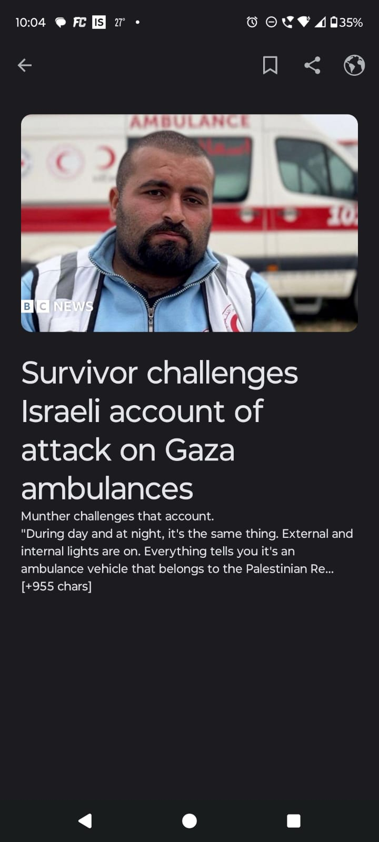

**Search Screen:-**

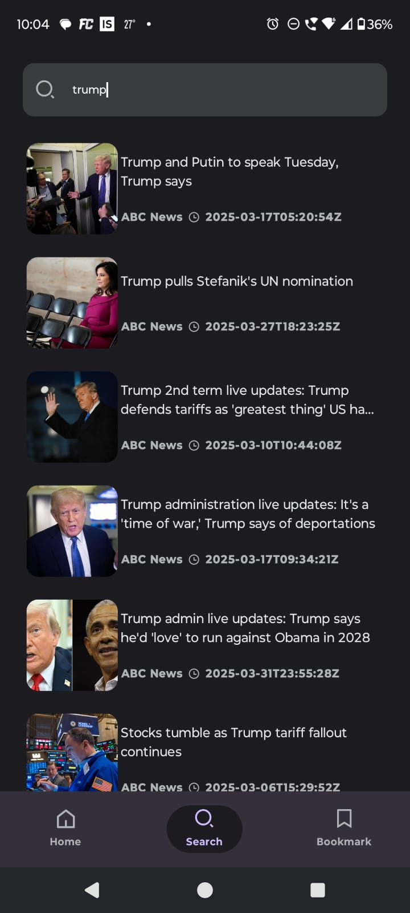

**Bookmark Screen**

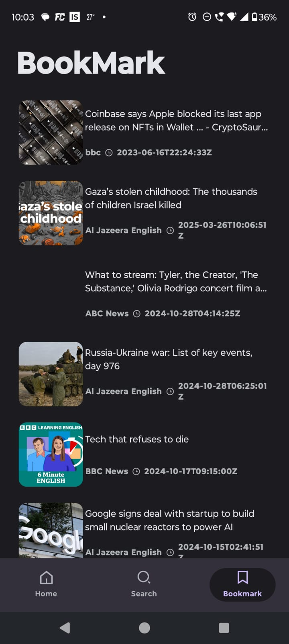

### **Observations and learning:**

#### **Observations:**

1. **Real-Time News Updates:**
   * Successfully fetched and displayed the latest news articles from external APIs.
   * Observed that API response time varies based on internet speed and server load.
   * Some APIs had rate limits, requiring efficient request handling.
2. **Category-Wise News Filtering:**
   * Users could filter news based on categories such as Sports, Technology, and Business.
   * Implementing filtering improved user experience by displaying only relevant news.
3. **Search Functionality:**
   * The search feature allowed users to find specific news articles quickly.
   * Observed that using indexing or caching improved search performance.
4. **Offline Reading:**
   * Successfully stored news articles in the local Room database for offline access.
   * Observed that large amounts of saved articles could slow down retrieval if not optimized.
5. **Push Notifications (FCM):**
   * Notifications were successfully sent and received for breaking news.
   * Observed that too many notifications led to user fatigue, requiring a balanced notification strategy.
6. **User Interface (UI) and Navigation:**
   * Implemented an intuitive UI using Jetpack Compose.
   * Observed that users preferred a minimalist design for easy navigation.

#### **Learning Outcomes:**

1. **Understanding API Integration:**
   * Learned how to fetch real-time data using Retrofit and handle API responses efficiently.
2. **Efficient State Management:**
   * Used ViewModel (MVVM architecture) to manage UI-related data effectively.
3. **Database Management:**
   * Learned how to store and retrieve news articles using Room Database.
   * Optimized queries to improve offline reading performance.
4. **Improving Performance:**
   * Implemented caching and pagination to improve app speed and efficiency.
5. **User Experience (UX) Best Practices:**
   * Understood the importance of clean UI design and smooth navigation.
   * Balanced push notifications to enhance engagement without overwhelming users.
6. **Cross-Platform Considerations:**
   * Explored cross-platform tools like Flutter for future app scalability.
7. **Deployment & Testing:**
   * Understood how to test and deploy Android applications on real devices.
   * Learned the importance of debugging and performance testing before release.

### **Conclusion:**

The development of the **News Application** provided valuable insights into mobile application development, API integration, and user experience design. The successful implementation of real-time news updates, category-wise filtering, offline reading, and push notifications demonstrated a comprehensive approach to delivering an efficient and user-friendly news platform.

Through this project, we achieved the following key outcomes:

1. **Seamless API Integration:** We effectively fetched real-time news from external sources using **Retrofit**, ensuring up-to-date content for users.
2. **Enhanced User Experience:** By implementing **category filtering, search functionality, and a clean UI**, we improved usability and engagement.
3. **Efficient Offline Storage:** The integration of the **Room database** allowed users to save articles for offline access, improving accessibility.
4. **Optimized Performance:** Using **ViewModel, Coroutines, and caching techniques**, we enhanced app speed and resource management.
5. **Push Notification Management:** We balanced notifications to keep users informed without causing notification fatigue.

### 